Flow/Volume. Design doc. Overview. R3

Update flow and energy based on analogue flow input and/or pulse input for volume.

Outputs:

Name | Unit | Range | Type | Subject | Note
System flow | m3/h | 0 – 6500 | Float | 305
Volume pulse counter total | Count | U32 (wrap) | U32 | 1025 | Save
Total volume | m3 | 0 – 1e+9-1 | U32 | 386 | Save
Free running volume | l | U32 (wrap) | U32 | 1026

Inputs:

Name | Unit | Range | Type | Subject | Note
No of running pumps | Count | 0 – 2 | U32 | 301
Measured flow | m3/h | 0 – 6500 | Float | 1027
Pit based flow | m3/h | 0 – 6500 | Float | 1016
Raw volume pulses | Count | U8 (wrap) | U32 | 1073 | From IO
Pulse/volume ratio config | p/1000m3 | 1 - 1e+9 | U32 | 1021 | Config
Pulse/volume ratio display | p/unit | 1 - 1e+6 | U32 | 1022 | Display, R/W
Pulse/volume unit | Enum | m3, l or gal | Enum | 1023 | Config, Display
Flow update time | s | 1 – 300 | U32 | 1024 | Config

Basic functionality:

Run every second.

If measured flow available
Then system flow = measured flow

Else if volume pulses available
Then system flow delta_pulses/delta_time

Else if pit based flow available
Then system flow = pit based flow

Else
System flow = not available

Flow/volume setting displays:

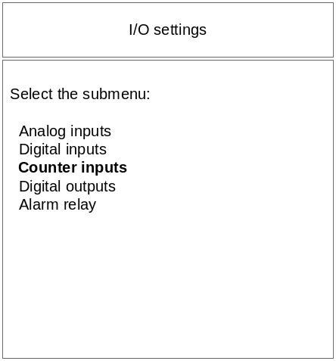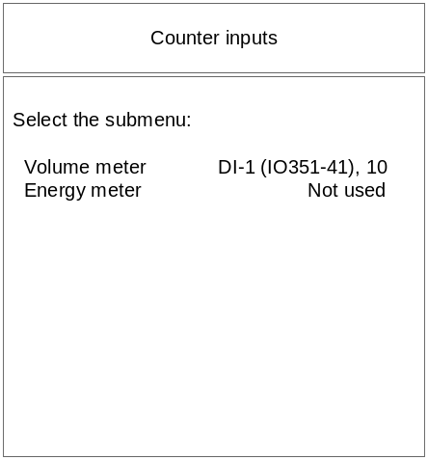

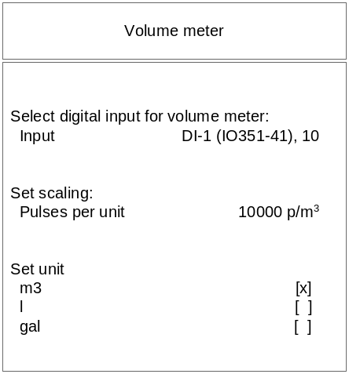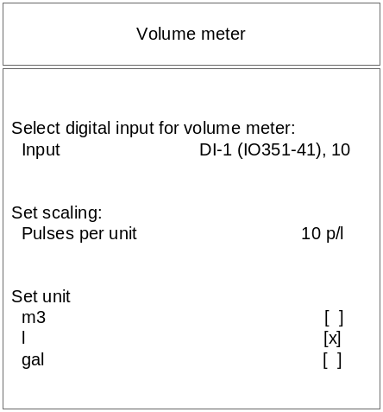

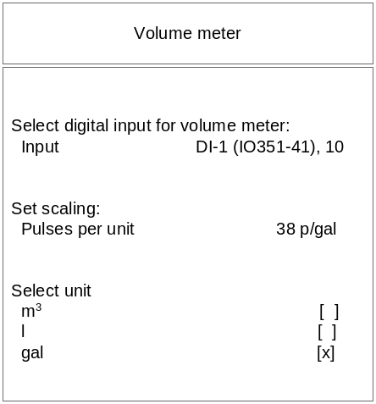

Flow/capacity

Flow calculation based on change in analogue input for pit level.

Outputs:

Name | Unit | Range | Type | Subject | Note
Pit based flow | m3/h | 0 – 6500 | Float | 1016 | (→ System flow)
In flow measurement time | s | 0 - 3600 | U32 | 1019
Pump 1 flow raw | m3/h | 0 – 6500 | Float | 1017
Pump 2 flow raw | m3/h | 0 – 6500 | Float | 1078
Pump 1 flow filtered | m3/h | 0 – 6500 | Float | 1018 | Save
Pump 2 flow filtered | m3/h | 0 – 6500 | Float | 1079 | Save
Pump 1 no of out flow calc | Count | 1e+9 | U32 | 1020 | Save
Pump 2 no of out flow calc | Count | 1e+9 | U32 | 1080 | Save
Pump 1 low flow warning |  |  | Alarm | 656
Pump 2 low flow warning |  |  | Alarm | 1077

Inputs:

Name | Unit | Range | Type | Subject | Note
Upper measurement pit level | m | 0- max level | Float | 350 | Config, Display
Lower measurement pit level | m | 0– max level | Float | 351 | Config, Display
Volume for flow measurement | m3 | 0.01 – 1e5 | Float | 1012 | Config, Display
Max flow measurement time | s | 1 – 86400 | U32 | 1013 | Config, Display
Flow min multiply | Ratio | 0-100 | U32 | 1014 | Config, Display
Flow max multiply | Ratio | 0-100 | U32 | 1015 | Config, Display
Measured pit level | m | 0– max level | Float | 1111
No of running pumps | Count | 0 – 2 | U32 | 301
Pump 1 actual operation mode |  |  |  | 297
Pump 2 actual operation mode |  |  |  | 298

Pit setting displays:

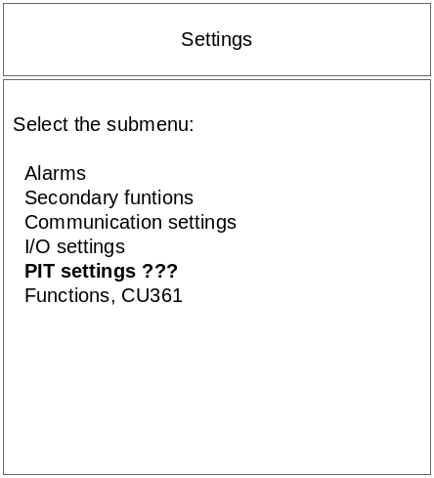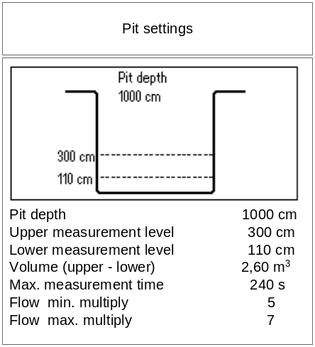

State machine:

- AWAIT_FILLING
- FILLING
- AWAIT_EMPTYING
- EMPTYING

Description:

AWAIT_FILLING:
This is the initial state. Also jump to this in case of invalid situations.

IF pumps are stopped AND level passes lover level upwards
THEN
- Start filling time count
- Next state = FILLING

FILLING:
IF level passes upper level upwards
THEN
- Calculate in-flow based on time count and filling time
- Next state = AWAIT_EMPTYING
Abort:
- A pump is started

AWAT_EMPTYING:
IF ONE pump is running and level passes upper level downwards
THEN
- Start emptying time count
- Next state = EMPTYING
Abort:
- Level passes lover level down
- More than one pump running

EMPTYING:
IF ONE pump is running and level passes lower level downwards
THEN
- IF:
- Filling time is less than max filling time
- Emptying time is within validation limits
THEN Calculate out-flow and filtered out-flow for the running pump
AND check low flow alarm
- Next state = AWAIT_FILLING
Abort:
- The pump is stopped
- Another pump is started

